# Updating the firmware for LD130

1. Start “ds30 Loader GUI.exe”
2. Choose the location of the firmware hex file
3. Choose the device type “dsPIC30F” and device model “6010A”
4. Choose ComPort speed (baud rate) 115200. **The bootloader is programmed to use only this speed. No other speed settings will work.**
5. Choose the ComPort number
6. Select “Write program”
7. When Ready, press **reset** button on LD130 and then click on “Download”

This is the screen with initial settings

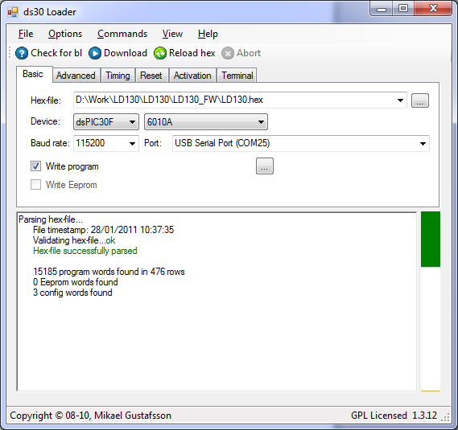

Updating in progress

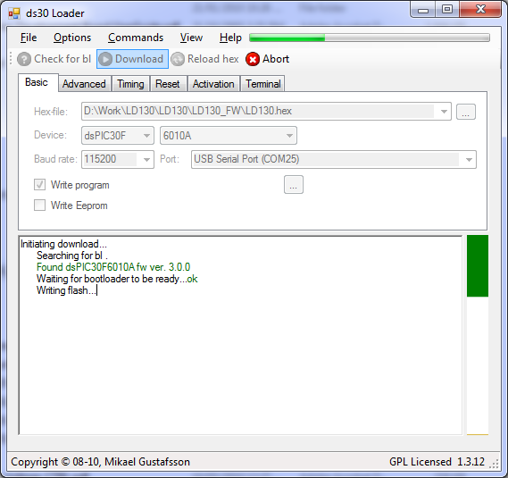

Updating Finished

